Data Derived Outlier Rules
IQR method first: working on a log scale because the data is heavily skewed. It broke down in two ways:
- Quantity: most purchases are exactly one item, so the middle half of the data is a single value and the IQR is 0. The method then falls back to percentiles, which flag a fixed share of rows (1% and 0.1%) however the data looks. That isn’t detecting outliers.
- No cut-off could answer the real question. 23,136 rows had quantity above 100, but only 2,582 were above 17,000. A single number can’t tell me whether those rows are errors, bulk buyers, or something else.
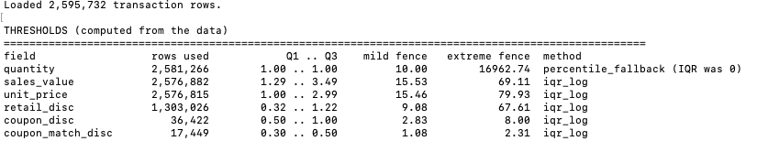
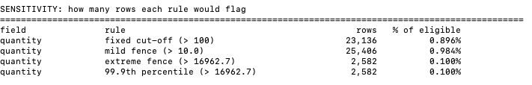

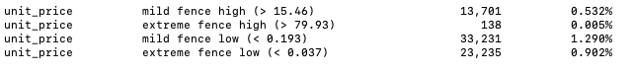

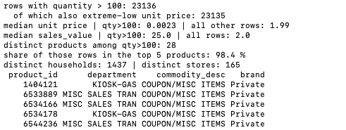

quantity isn’t an item count
→changed the logic
The agent now first separates non-merchandise products (29,637 rows, 1.14% of all transactions), then fits the cut-offs on ordinary merchandise only. Coupon discounts use only the extreme level. The same investigation explained the other flags:
- 26 of the 36 “positive discounts” were floating-point noise, so I added a half-cent tolerance. That leaves 10.
- 14,399 rows are zero lines with no quantity and no sales. 7,839 of them belong to 15 products with no category.
- 4,451 rows are free or fully discounted items.
New result of outlier.py
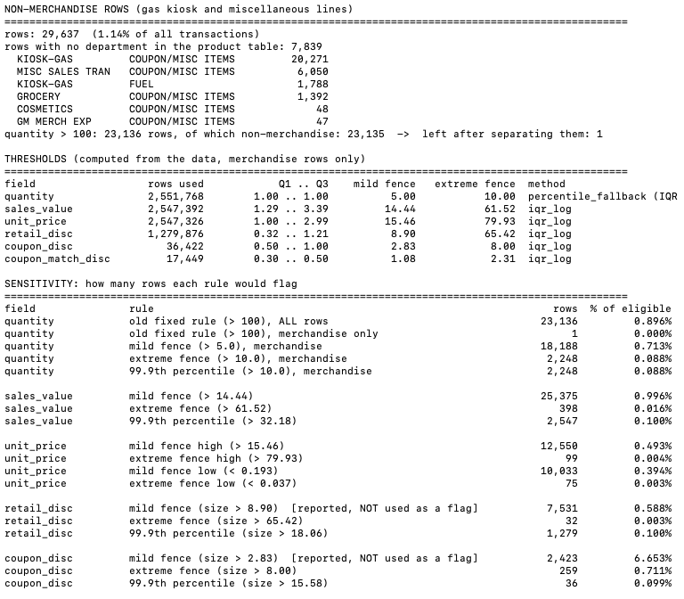

 | Before | After
Quantity extreme fence | 16,963 | 10
Quantity above 100 | 23,136 | 1
Extreme-low unit price | 23,235 | 75

Before: fence fitted on all rows, stretched by gas and misc lines. After: fitted on merchandise only.

Summary: what changed
I did not remove outlier detection. I changed which rows the cut-offs are calculated on.
Before: I used a fixed cut-off of 100 (hypothetical threshold without any test) on quantity, applied to every row. It flagged 23,136 rows, and 23,135 of them were gas-kiosk and miscellaneous lines, where quantity is not an item count (the median unit price is $0.0023, against $1.99 for ordinary products).
Now:
- The agent first separates non-merchandise lines (29,637 rows, 1.14% of all transactions). These are a different kind of product, not outliers, so they are marked and left out of the outlier calculation.
- On ordinary merchandise only, it sets a cut-off for each field from the data: log-scale IQR for sales value and unit price, and percentiles for quantity, because most quantities are exactly 1 and the IQR is 0. Discount columns use only the extreme level, since coupon values are set face amounts.
- Rows above the cut-offs get a “watch” flag (2,946 rows). Nothing is deleted. The Feature Agent decides later whether to cap them.
Result: rows with quantity above 100 dropped from 23,136 to 1, and extreme-low unit price rows dropped from 23,235 to 75. The quantity watch flag is a watch list, not a claim that those rows are wrong, because percentile cut-offs flag a fixed share of rows by construction.

Data Anomalies (Positive discount)
Data anomalies: rules the agent applies on its own
Issue | Rule | Rows
Discount positive only by rounding noise | Half-cent tolerance; ignored | 26
Sales value positive only by rounding noise (no quantity) | Same tolerance; ignored | 29
Positive discount, quantity 0 | Flagged as a price-adjustment line | 8
Quantity 0 and sales 0 | Flagged as a zero line (voided or placeholder) | 14,399
Quantity but no sales | Flagged as a free or fully discounted item | 4,451
Positive discount, normal quantity | If the flipped sign gives a normal share of the shelf price, flagged as a probable sign typo; corrected value in a new column | 2
Quantity 0, but sales look normal for the product | Flagged as probably missing quantity; money kept | 7
“Normal” is measured from the data (mild IQR fence), not a fixed number. Original columns are never overwritten.
Updated decision log
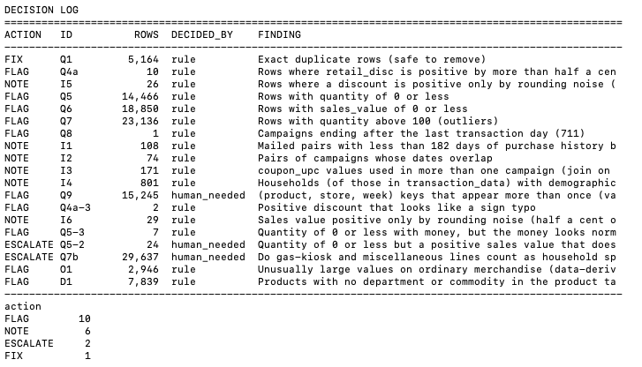

Only Q7b changes the model
The Escalates
- Q7b: Gas and miscellaneous lines (29,637 rows): do they count as household spend? This changes every spend-based feature. My suggested default is to keep them marked, exclude them from the main spend features, and offer a separate fuel and misc feature.
- Q5-2: Quantity 0 with a small real amount (24 rows, $0.02 to $0.50): no rule can decide these. My suggested default is to keep the money and ignore the quantity.
- Q9: Conflicting in-store display records (15,245 rows): not used in the first model, so low priority.
Caveats
- The sign-typo and missing-quantity fixes are probable, not confirmed. I’d like the mentor to confirm the rule.
- Quantity cut-offs use percentiles, because most quantities are 1 and the IQR is 0. That flags a fixed share of rows, so it is a watch list, not a claim that those rows are wrong.

